**DEVOPS COURSE CAPSTONE PROJECT**

**TASK 0: INSTALLING REQUIRED SOFTWARES**

1. AWS CLI:

curl "https://awscli.amazonaws.com/awscli-exe-linux-x86_64.zip" -o "awscliv2.zip"  
unzip awscliv2.zip  
sudo ./aws/install  
aws –version

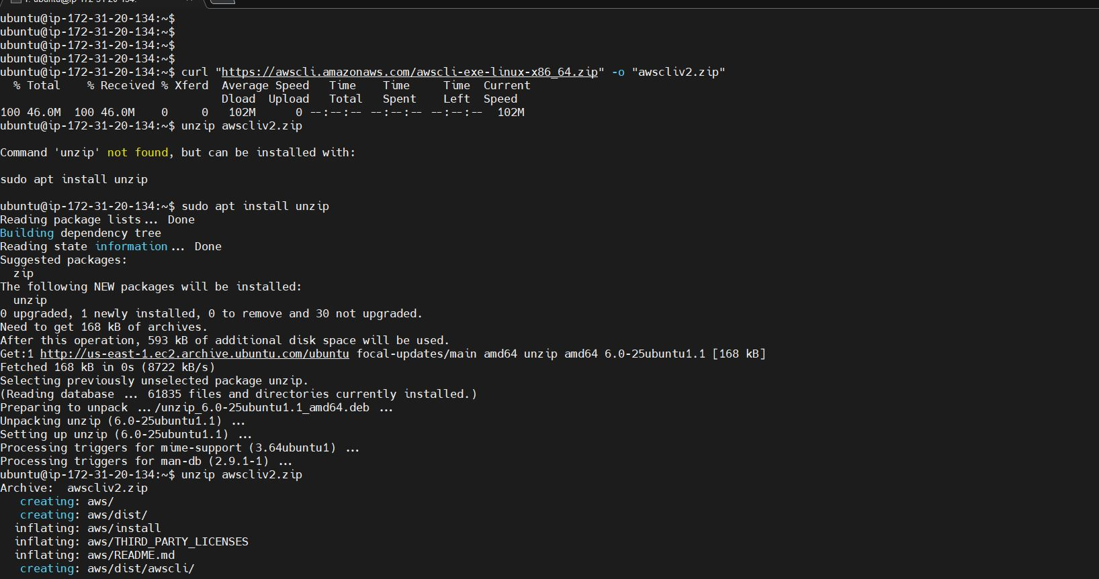



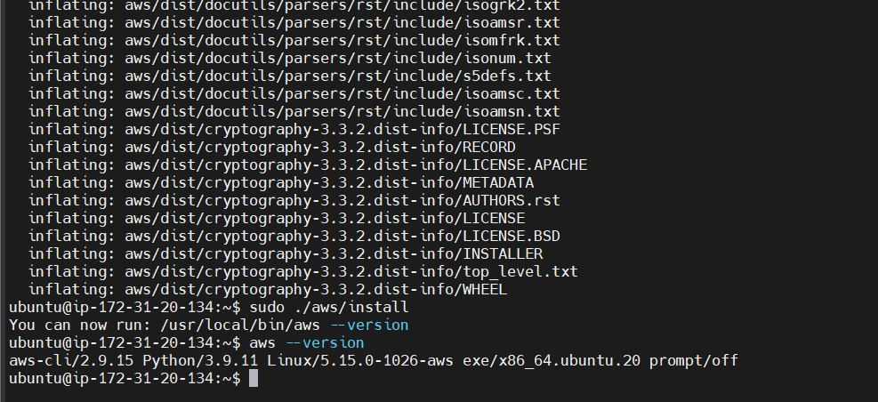

1. TERRAFORM:

sudo apt-get update && sudo apt-get install -y gnupg software-properties-common curl

curl -fsSL https://apt.releases.hashicorp.com/gpg | sudo apt-key add -

sudo apt-add-repository "deb [arch=amd64] https://apt.releases.hashicorp.com $(lsb_release -cs) main"

sudo apt-get update && sudo apt-get install terraform -y

terraform -help

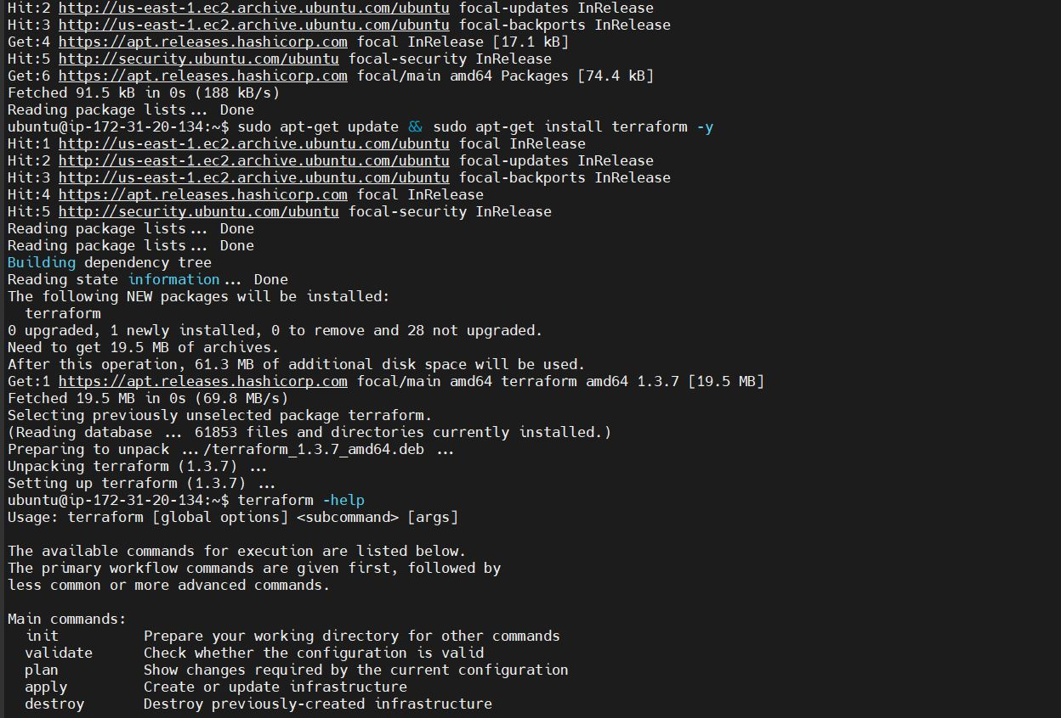

1. KUBECTL:

curl -o kubectl https://amazon-eks.s3.us-west-2.amazonaws.com/1.21.2/2021-07-05/bin/linux/amd64/kubectl

curl -o kubectl.sha256 https://amazon-eks.s3.us-west-2.amazonaws.com/1.21.2/2021-07-05/bin/linux/amd64/kubectl.sha256

openssl sha1 -sha256 kubectl

chmod +x ./kubectl

mkdir -p $HOME/bin && cp ./kubectl $HOME/bin/kubectl && export PATH=$PATH:$HOME/bin

echo 'export PATH=$PATH:$HOME/bin' >> ~/.bashrc

kubectl version --short –client

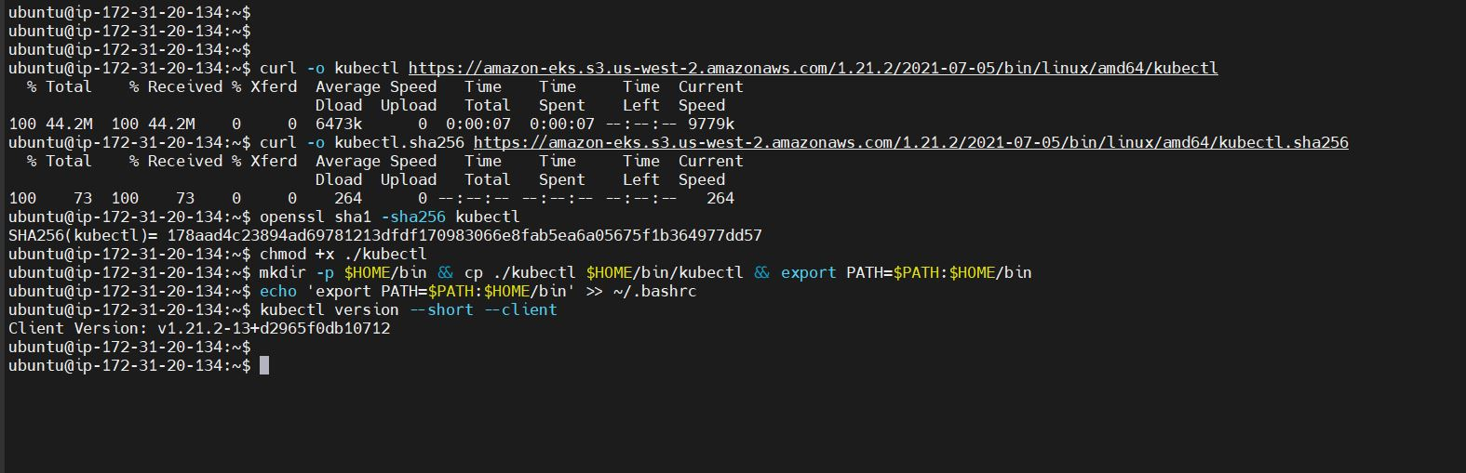

1. EKSTCL:

curl --silent --location "https://github.com/weaveworks/eksctl/releases/latest/download/eksctl_$(uname -s)_amd64.tar.gz" | tar xz -C /tmp

sudo mv /tmp/eksctl /usr/local/bin

eksctl version

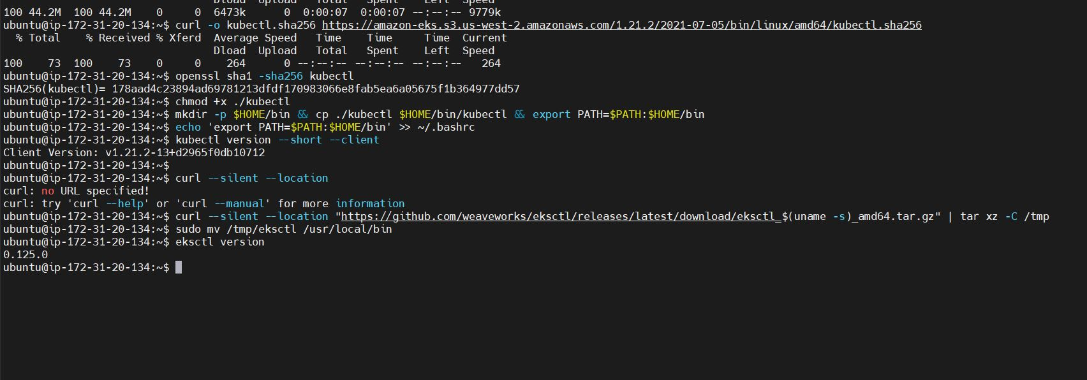

1. Helm:

curl https://baltocdn.com/helm/signing.asc | sudo apt-key add -

sudo apt-get install apt-transport-https --yes

echo "deb https://baltocdn.com/helm/stable/debian/ all main" | sudo tee /etc/apt/sources.list.d/helm-stable-debian.list

sudo apt-get update

sudo apt-get install helm -y

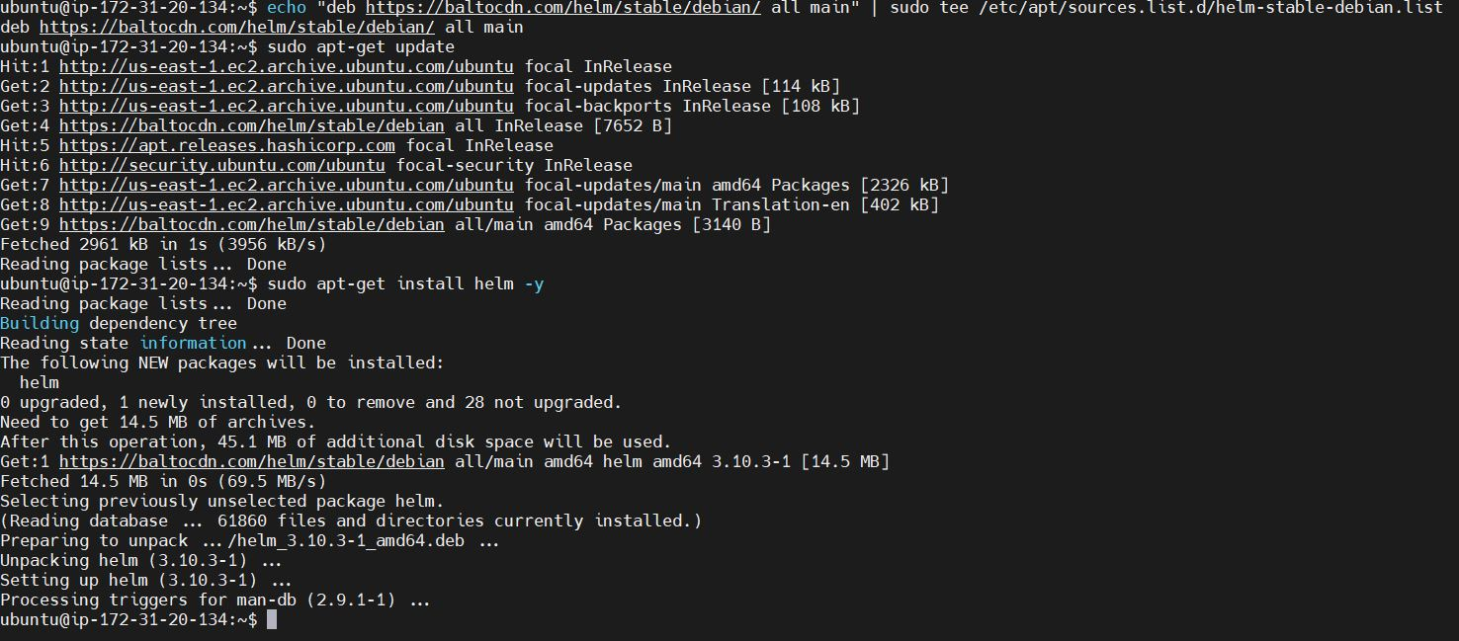

1. Apache Benchmark ( AB)

apt-get update

apt-get install apache2-utils -y

ab -V

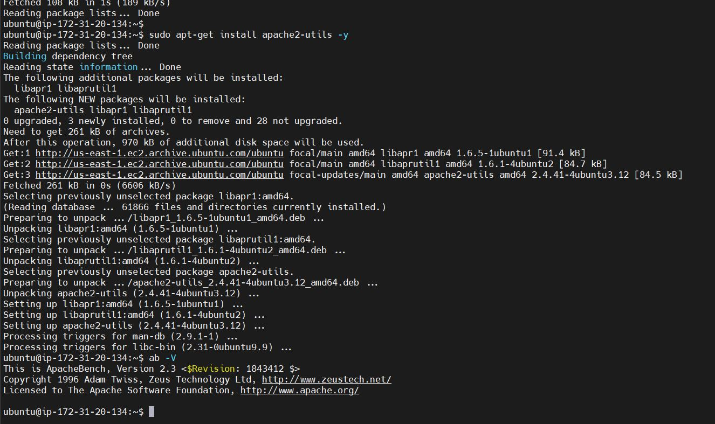

Additional Notes: All the above tools which are installed manually can be installed using terraform remote provisioner. As a practice verified same.

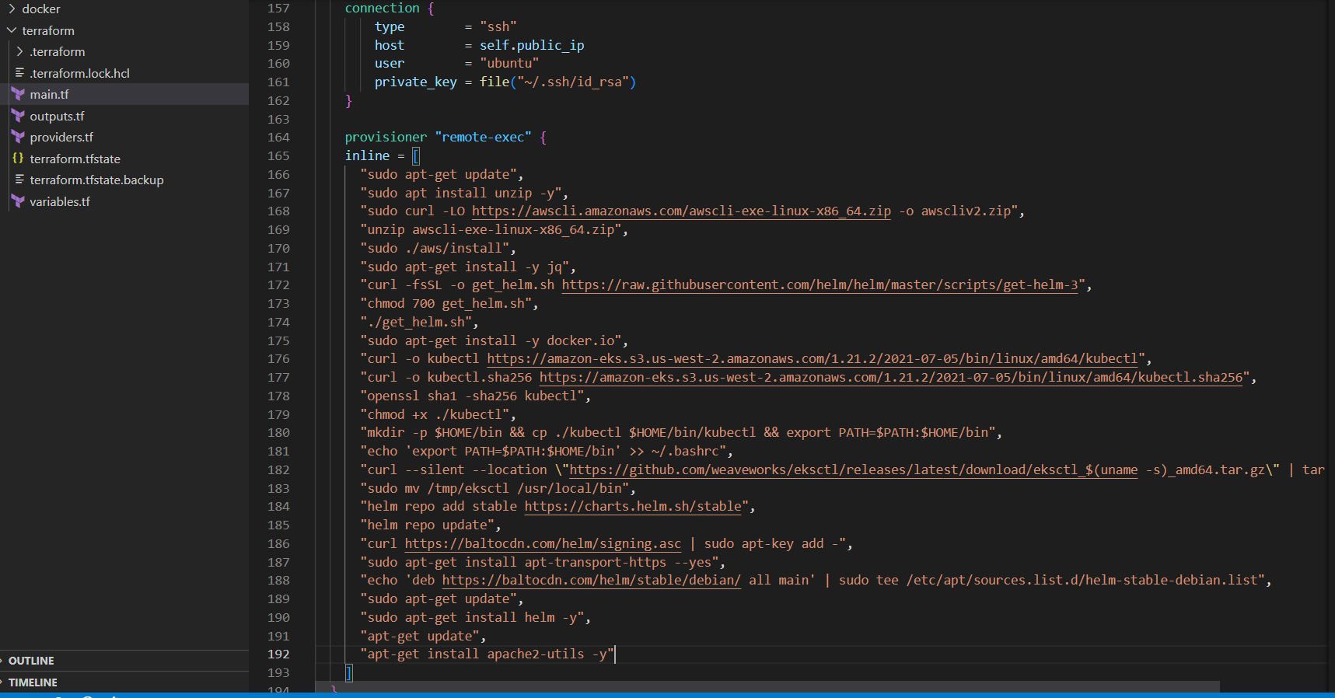

**Task 1: Setup EKS Cluster**

Configured AWS credentials

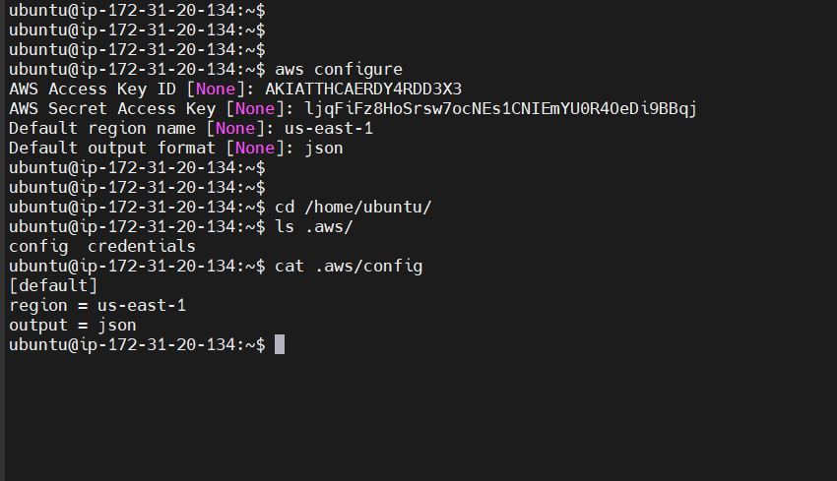

Now used terraform init, terraform plan and terraform apply commands to create the VPC, s3 bucket, subnets (2 private and 2 public), internet gateway, route tables for the subnets, Nat gateway using the terraform .tf files.

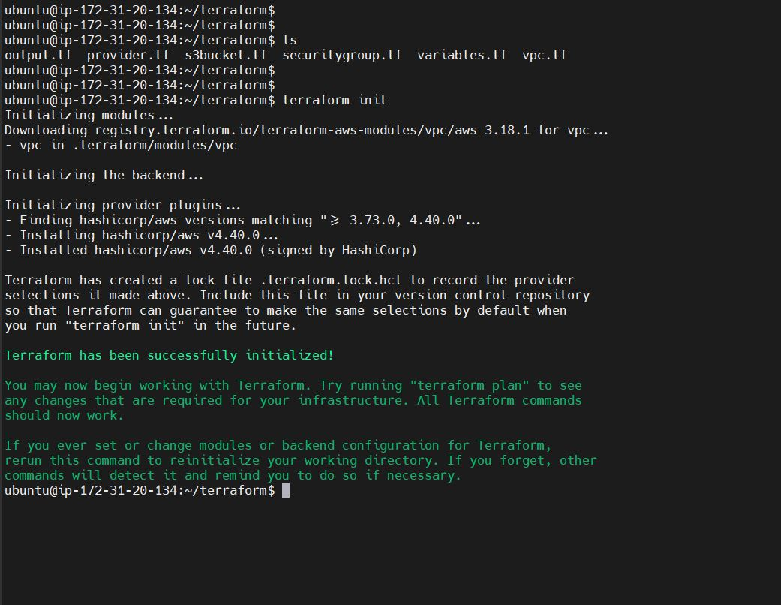

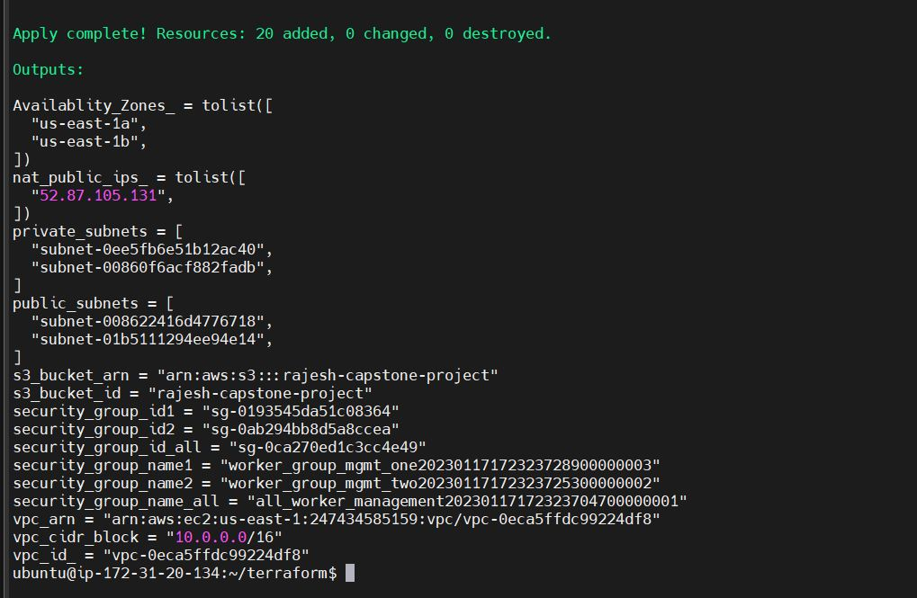

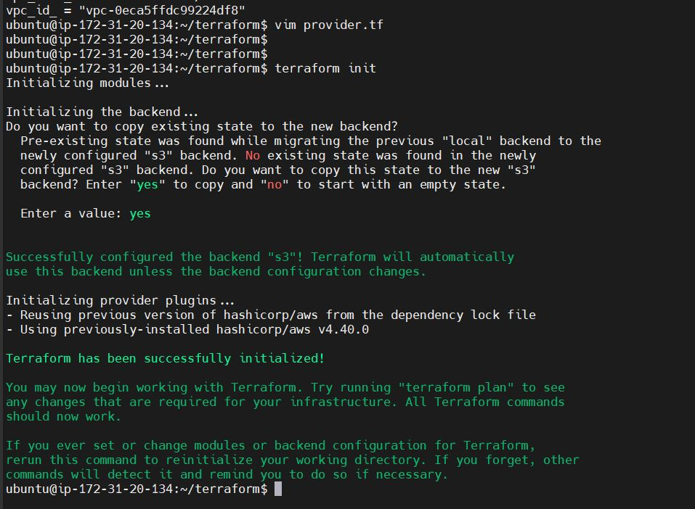

VPC:

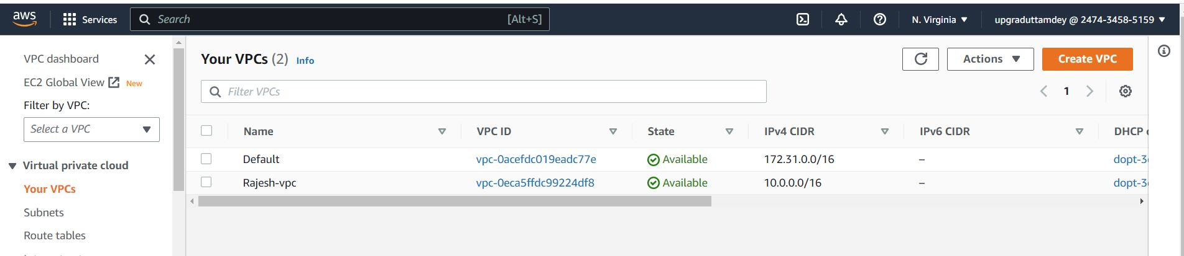

VPC tags:

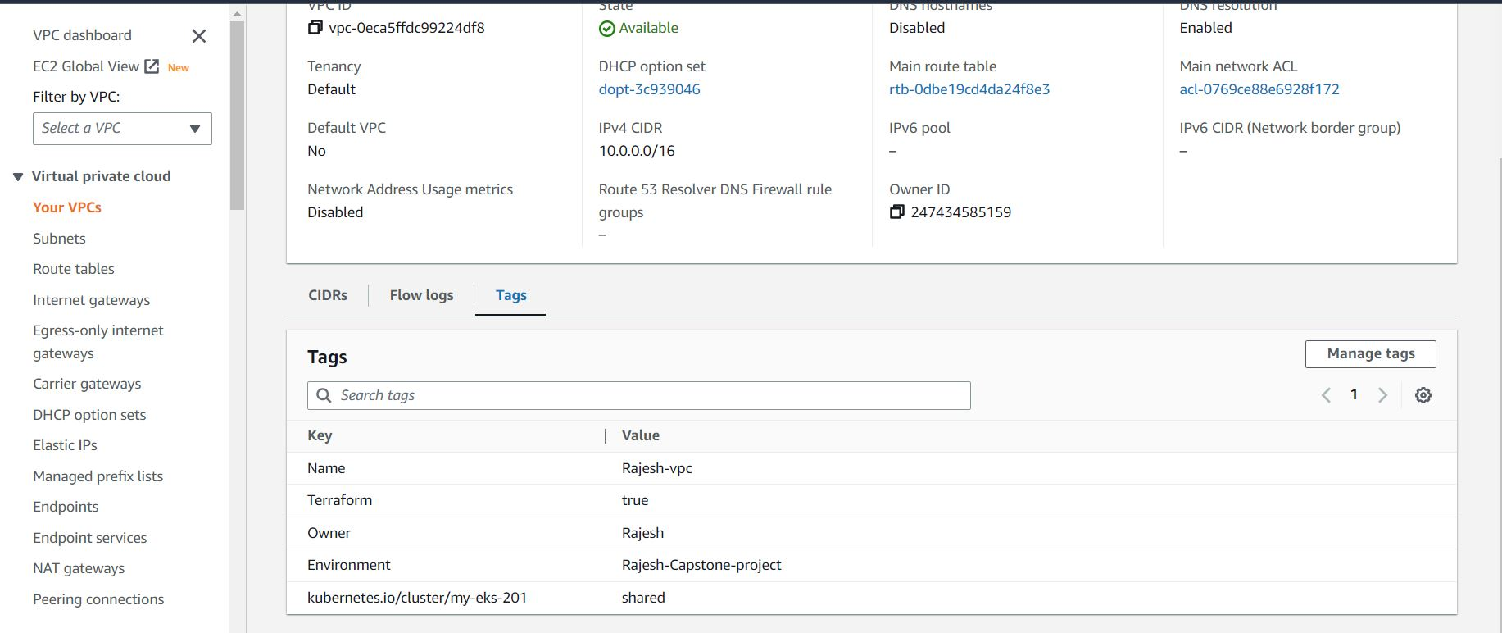

Subnets:

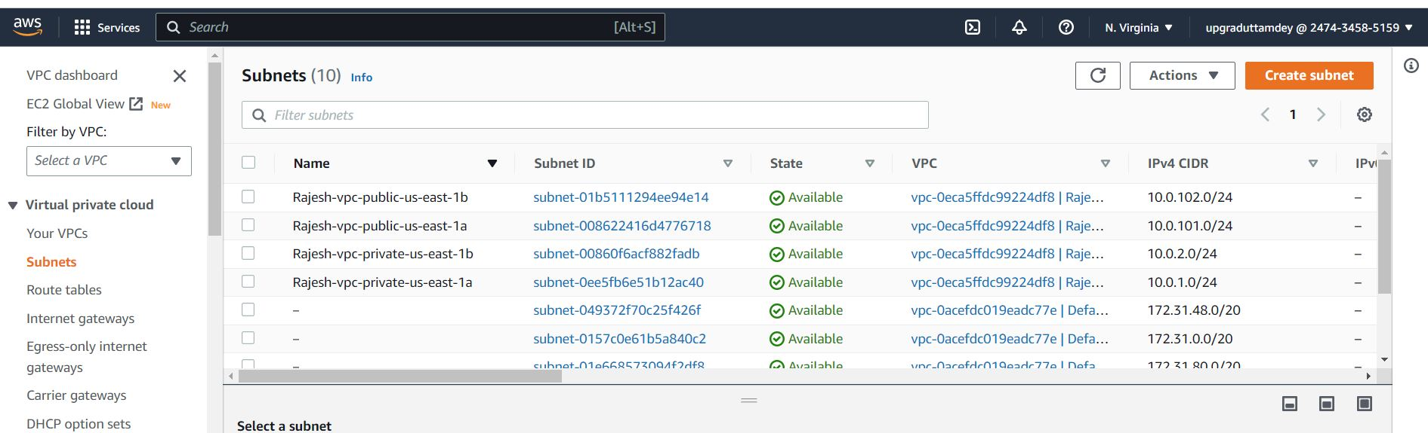

Route tables:

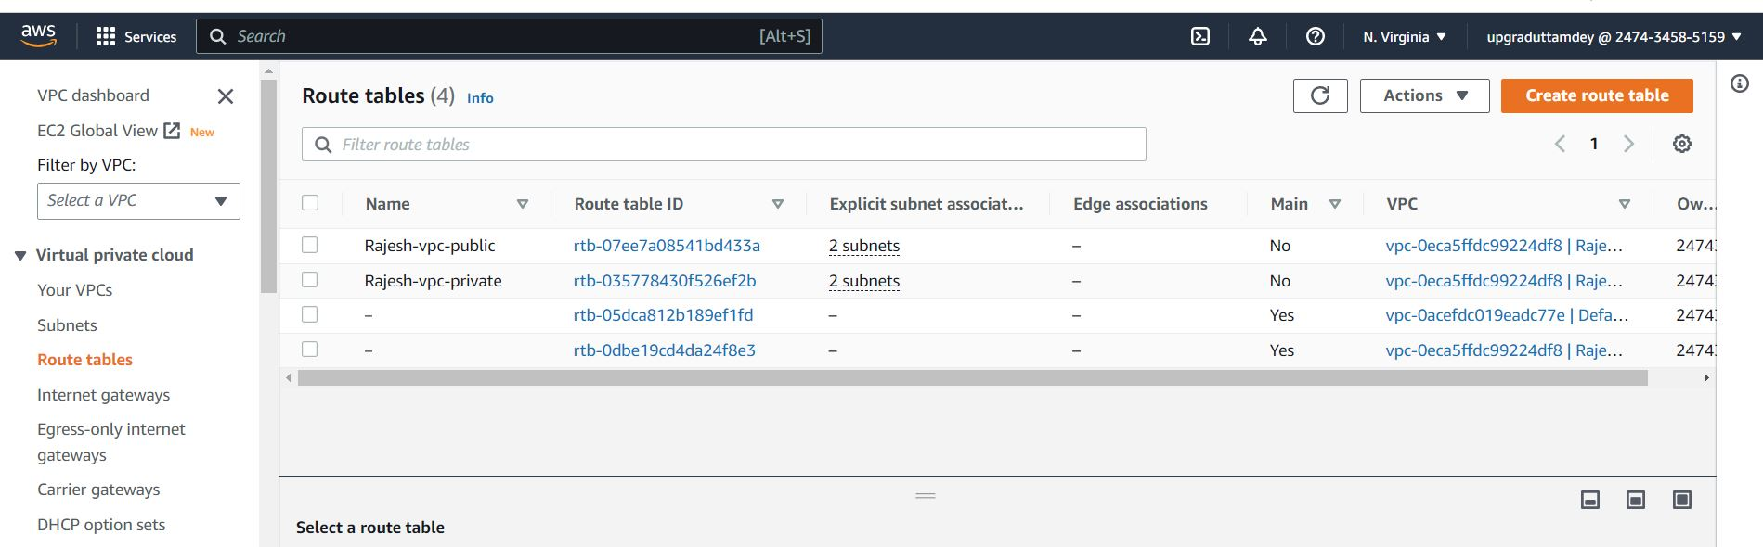

Nat gateway:

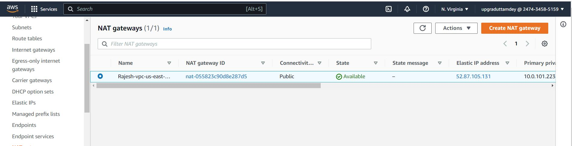

IGW

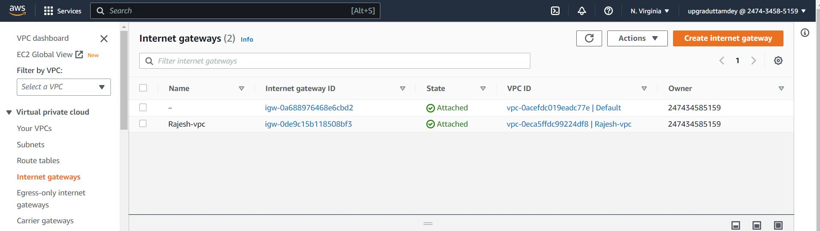

S3 bucket:

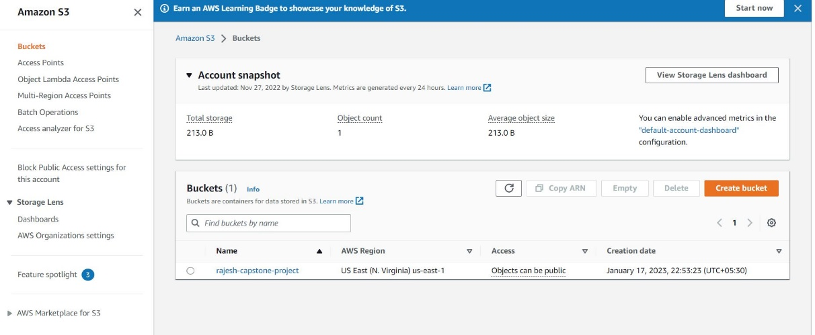

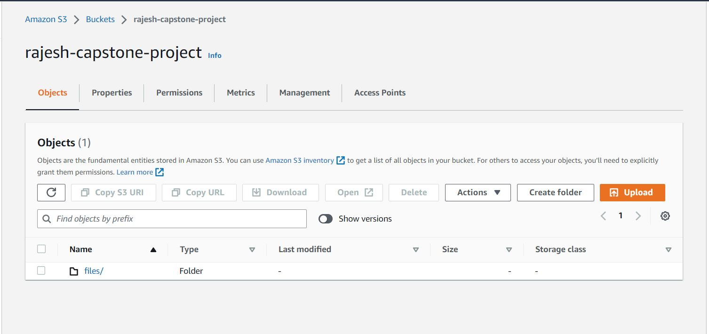

Create EKS Cluster with the help of cluster configuration yaml file.

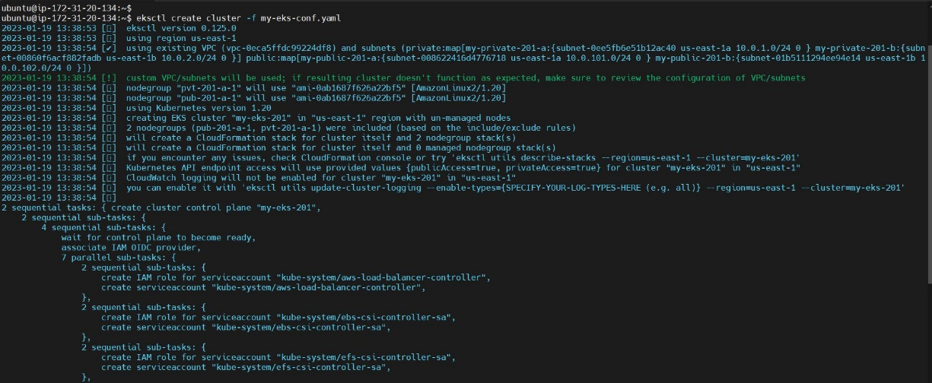

Cluster creation…Wait for about 20 minutes for the cluster to be ready:

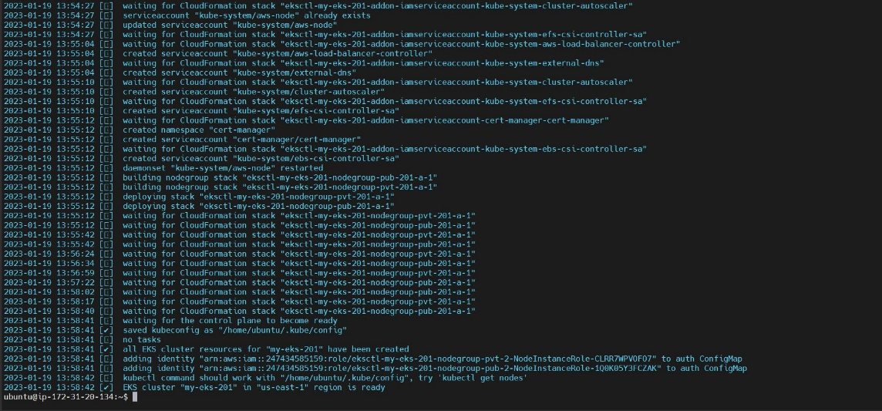

Check in EKS AWS Console:

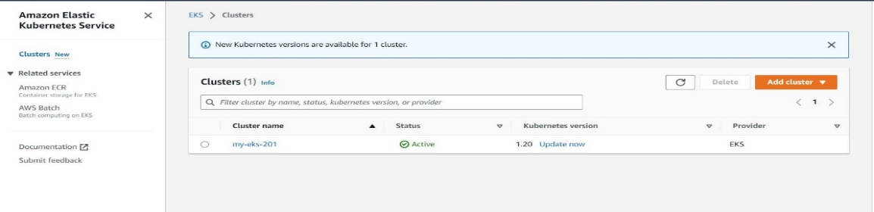

Updation of kubeconfig file for the cluster

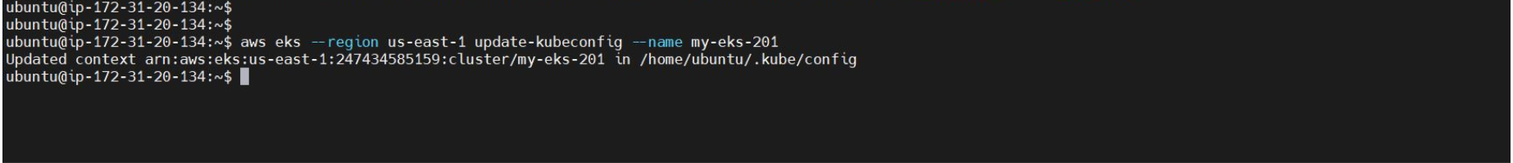

Verification of pods after cluster created. Kubectl get pods -n kube-system

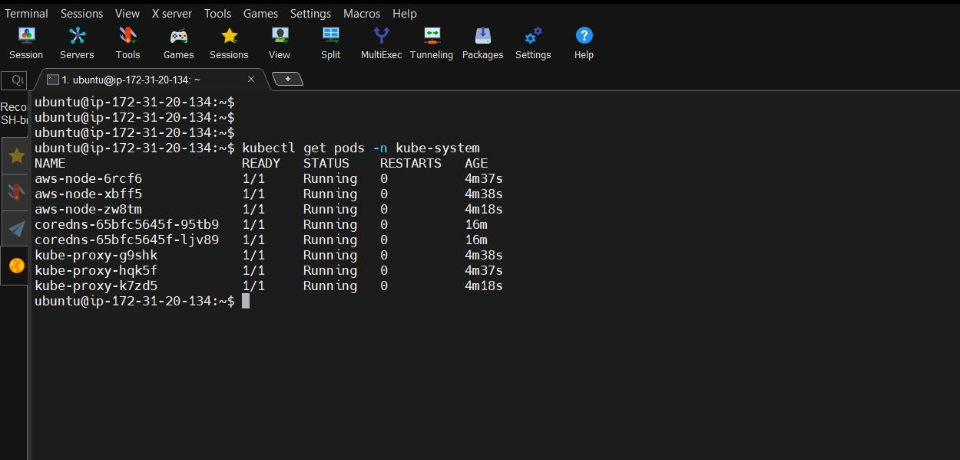

Associate OIDC provider:

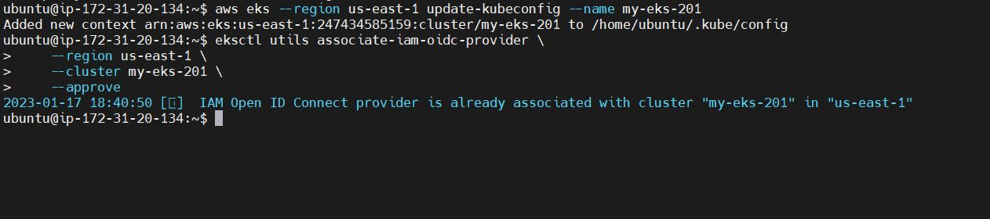

Create ALB policy, Create service account for ALB , AWS-ALB-Installed

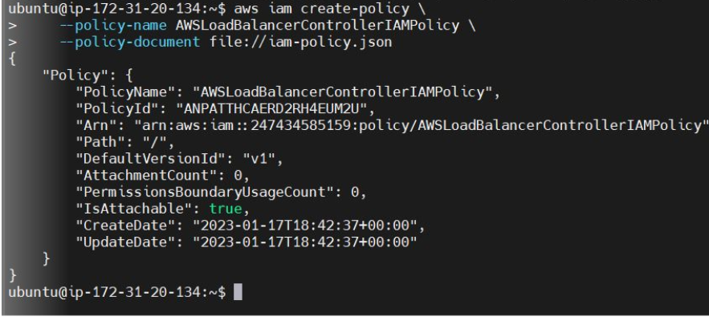

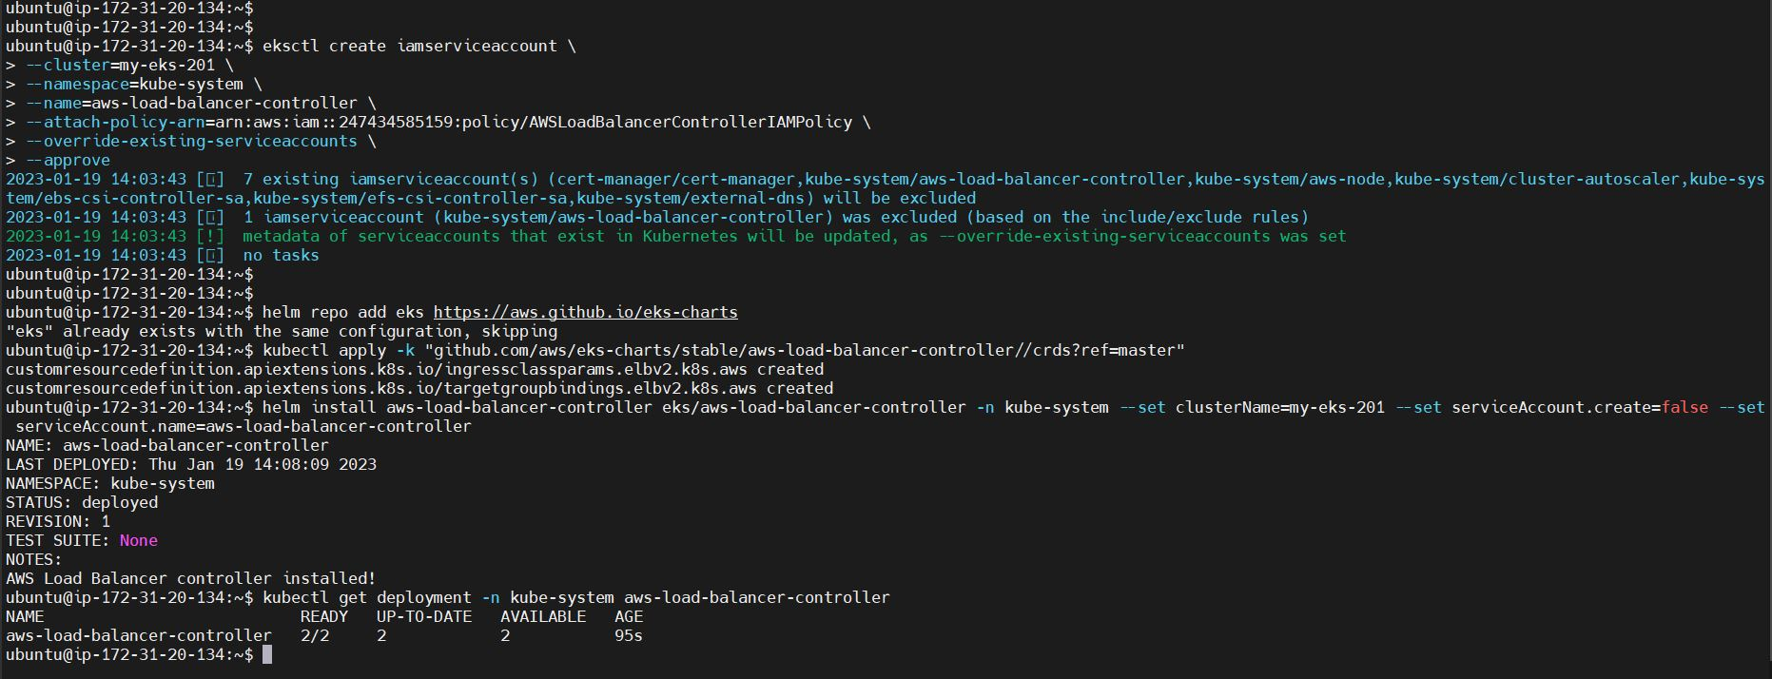

Kubernetes-metric-server

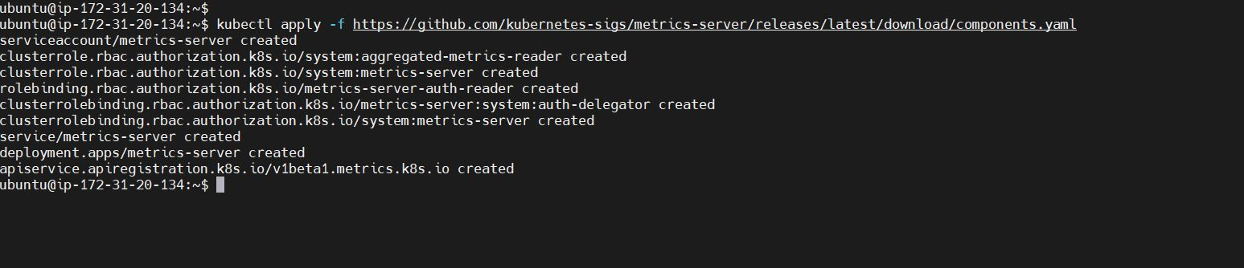

Cluster Auto-scaler

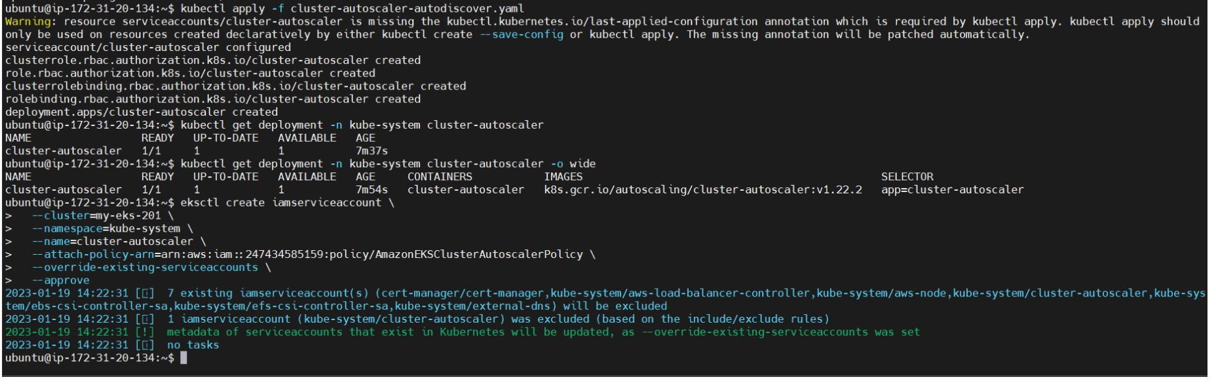

**Task 2: Deployment of sample node application**

Create ECR repository in AWS: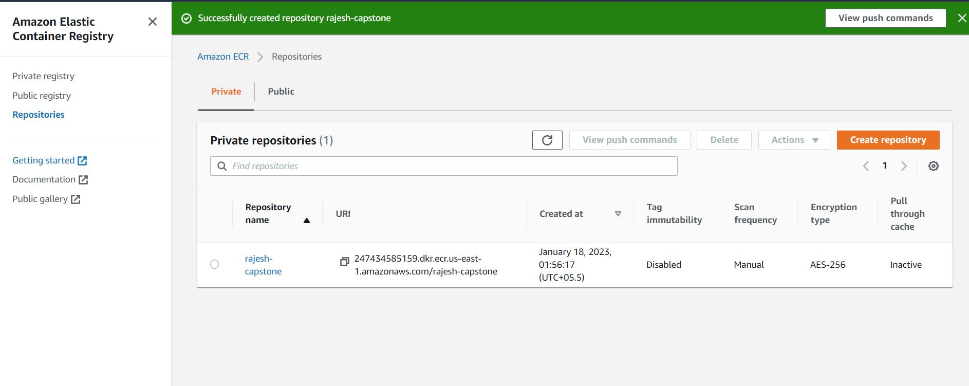

Create Docker file:

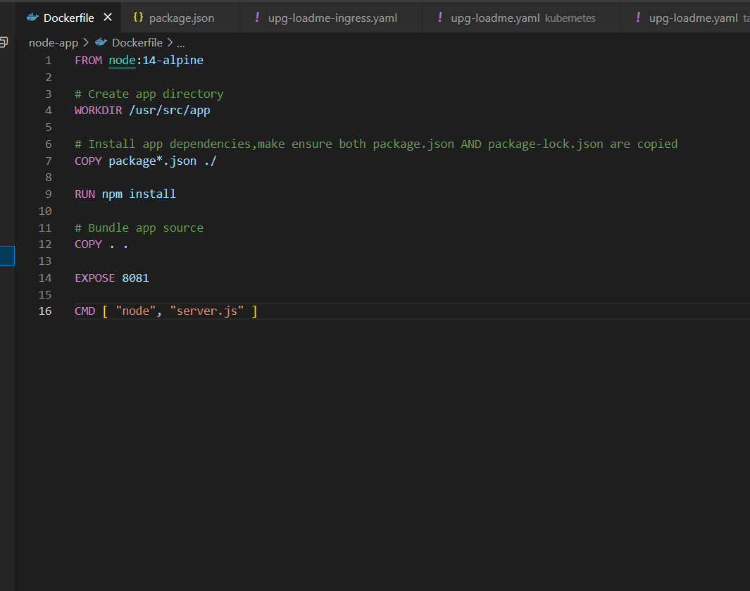

Build and Docker Image

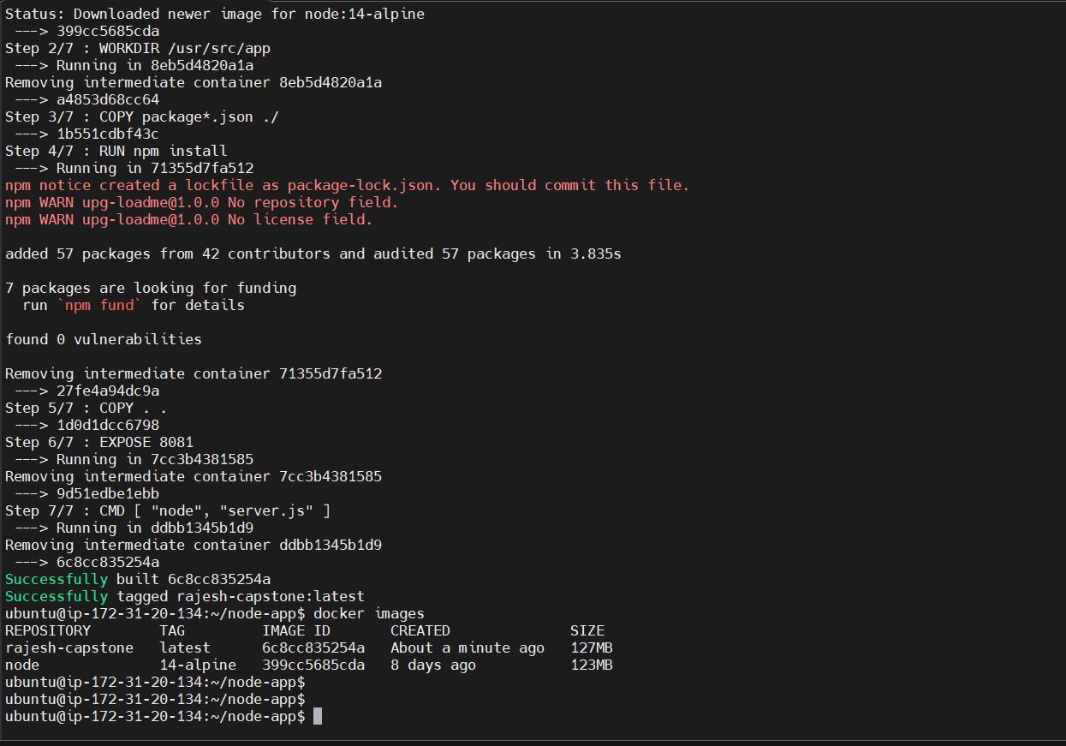

Authenticate ECR repo through aws_cli and tag and push the docker image:

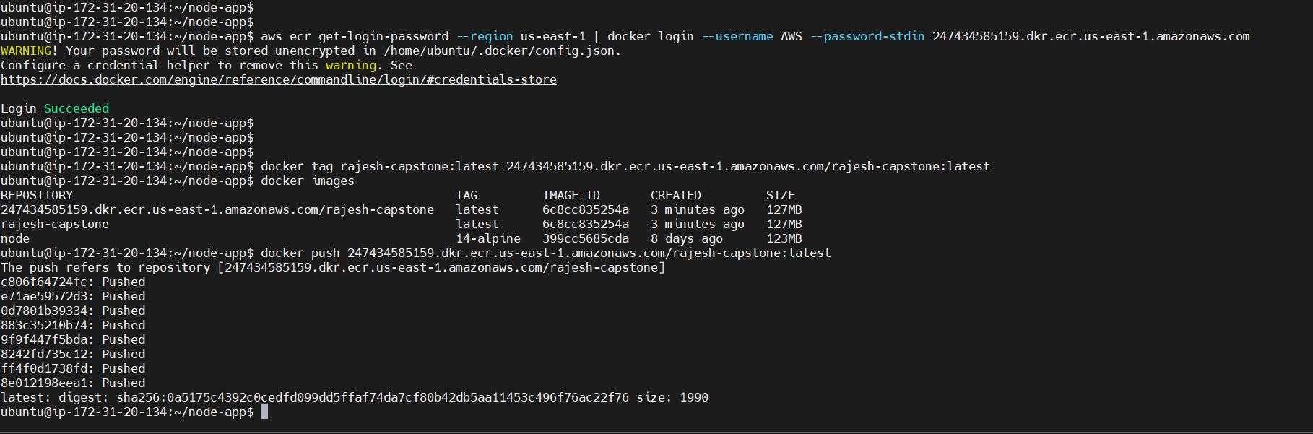

ECR Image:

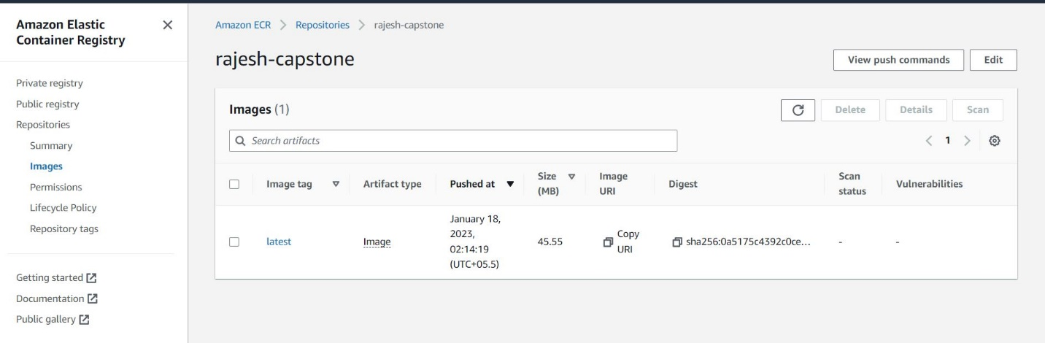

Run docker image to check the application: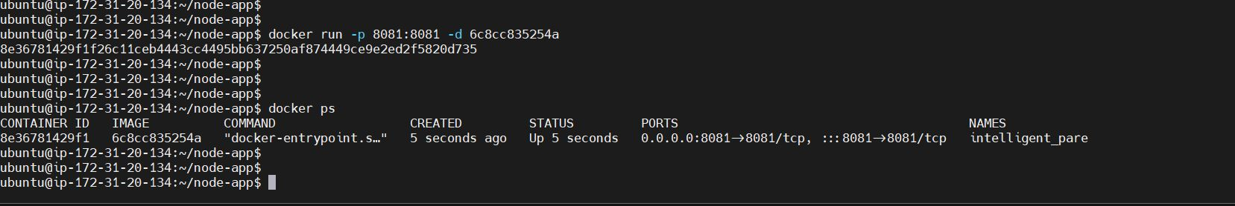

Verification of Application on browser through Docker PS command

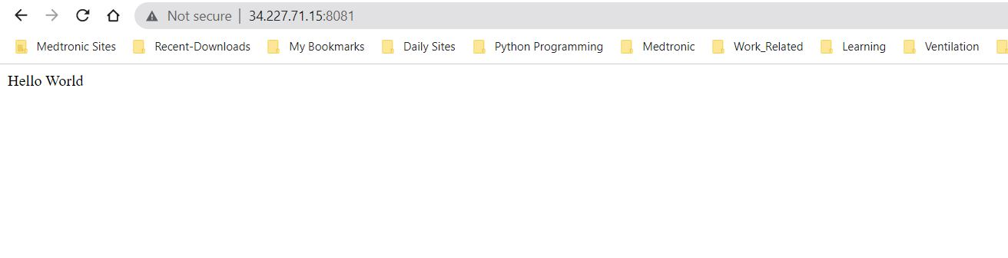

Creating the node group by adding below code into the config file:

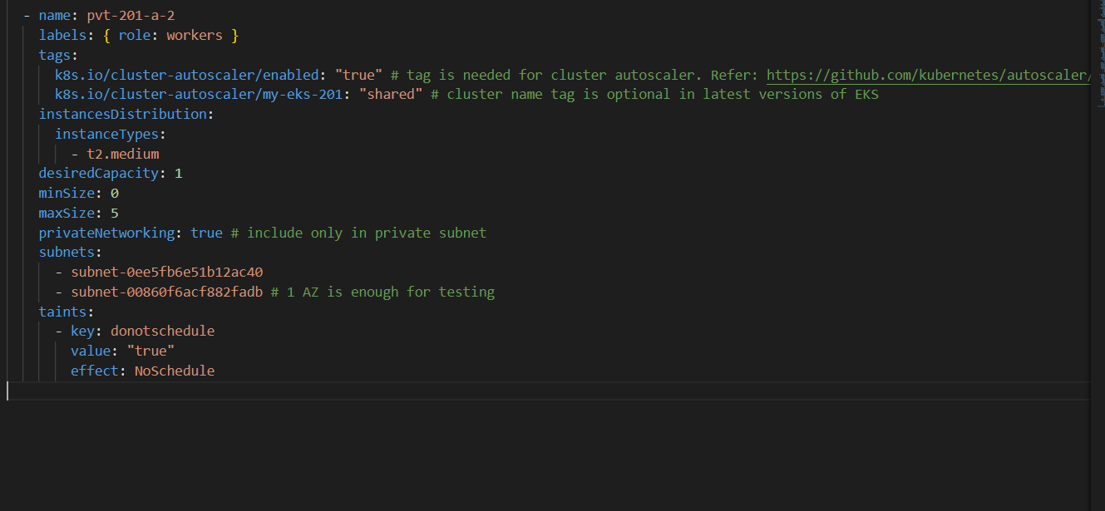

node group Creation

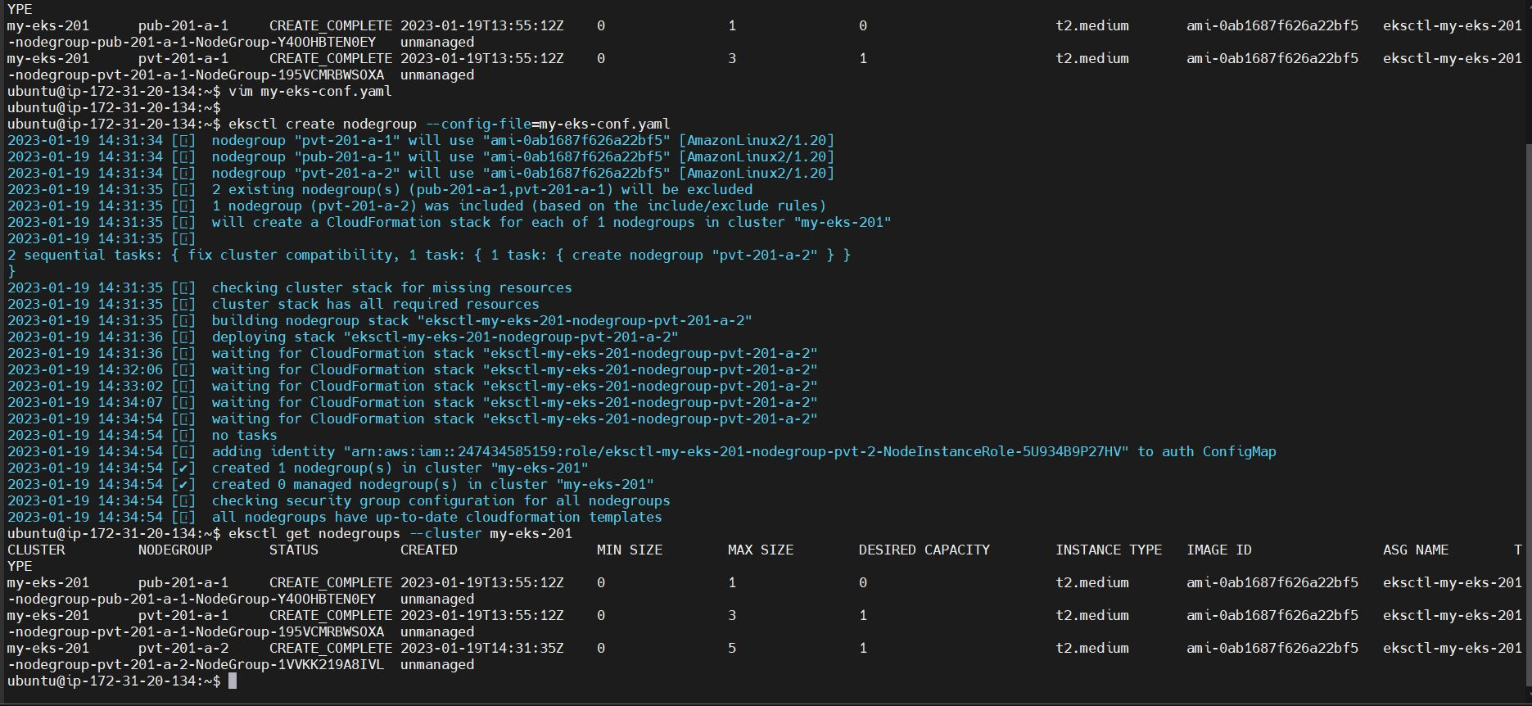

Created/Updated deployment, service and ingress yaml files for the app image uploaded into ECR repo.

Deploy the files using “kubectl apply -f <file-name.yaml>”

Create the demo namespace and Verification of cluster pods:

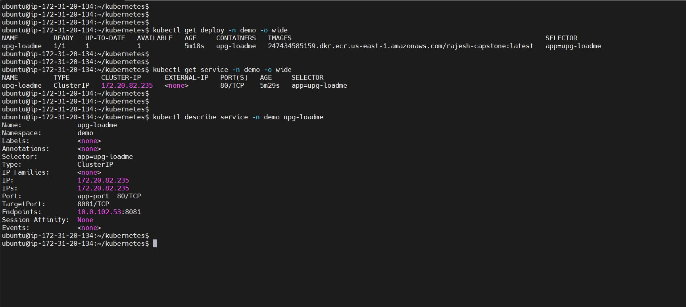

Load balancer DNS name and check the output in the browser

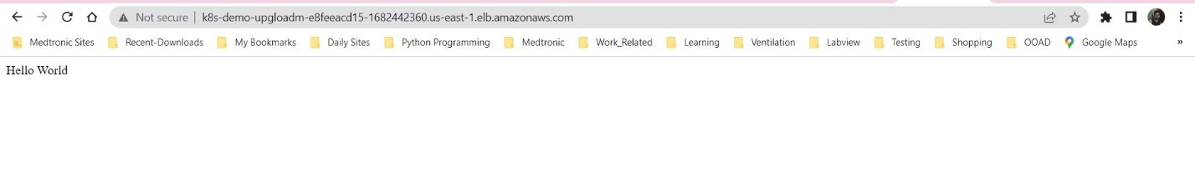

upg-loadme-ingress output check :

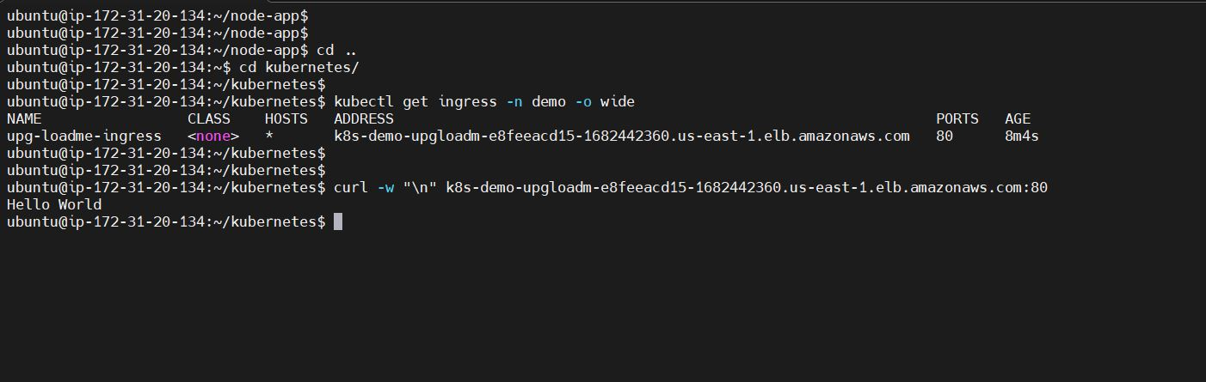

**TASK 3: Deploy Redis server on Kubernetes**

Notes: Deployment of stateful set Redis Server can be done in 2 ways

**Method 1**: By using the Helm i.e Deployment stateful set of Redis

Entering some data into the stateful set by using RedisCli commands ( this can be done by creating redis pod i.e kubectl run redis - - image redis)

Now connect this redis pod to stateful set and verify the data

Delete the stateful set pods and check for New Pods coming up

Verifying the retrieve of data on new pods

helm repo add my-repo <https://charts.bitnami.com/bitnami>

helm install my-release my-repo/redis -f redis.yaml

created a redis.yaml for stateful set of data

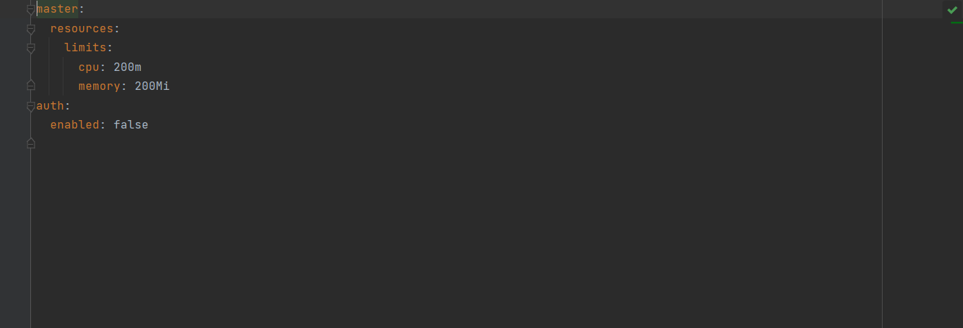

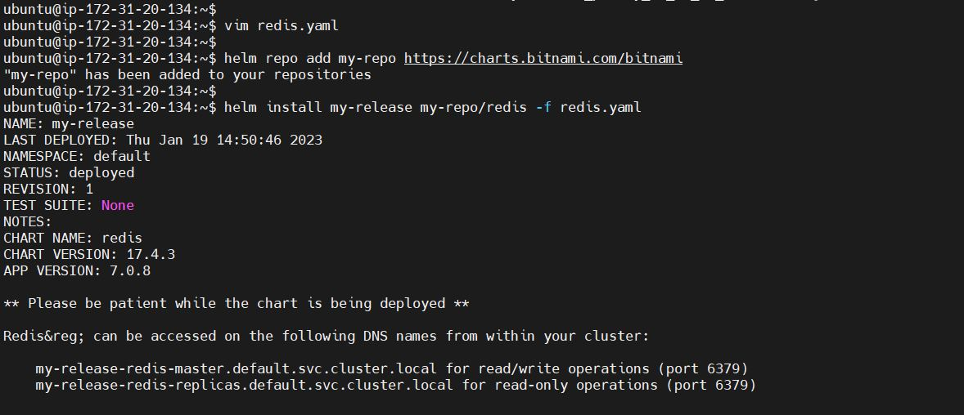

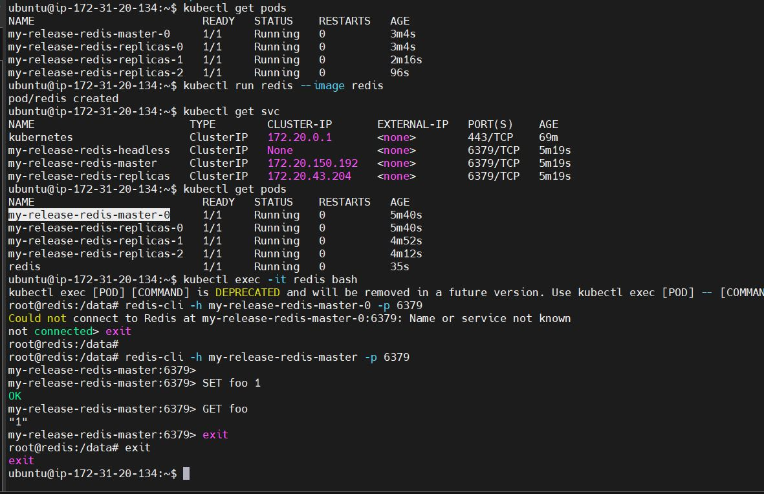

Delete the pods and check for the new redis-cli pod created and login to it to check that the previously set foo key value is still 1 showing that the data is persisted:

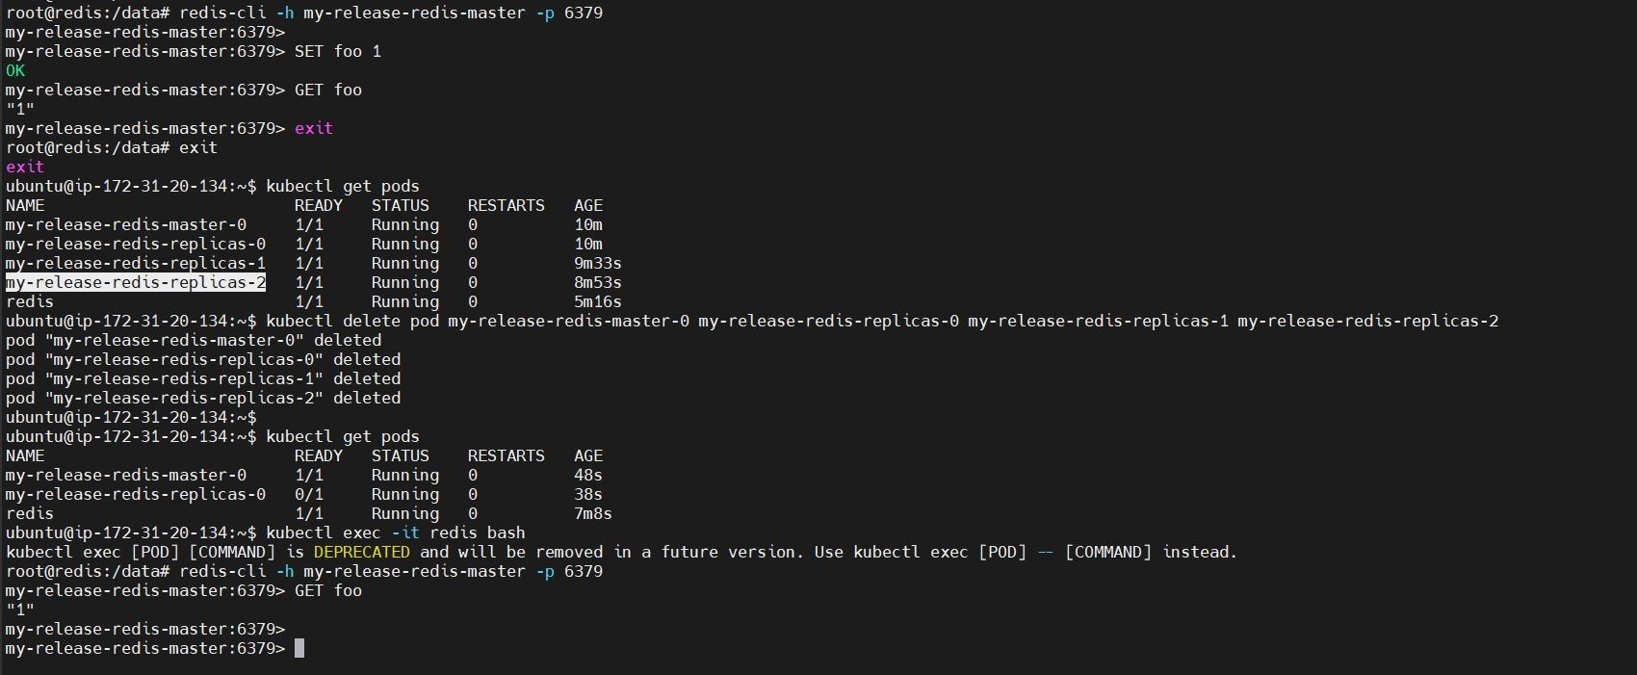

Method 2:

First create an EBS volume of required/desired memory using aws_cli:

aws ec2 create-volume --region us-east-1 --availability-zone=us-east-1a --size=11 --volume-type=gp2

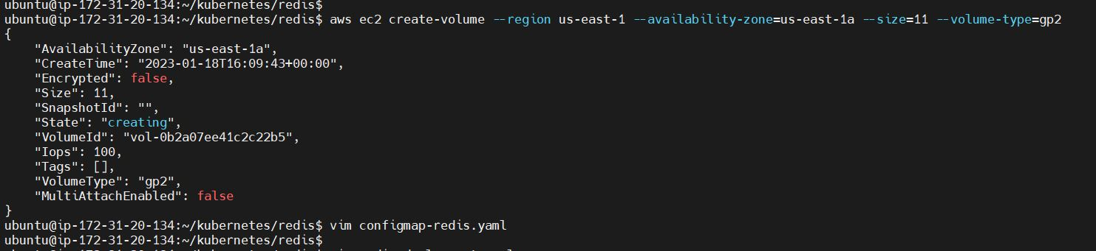

Then Create the configmap.yaml , storage-class.yaml (pv and pvc), redis service.yaml and

statefulset-server-redis.yaml

Redis files created:

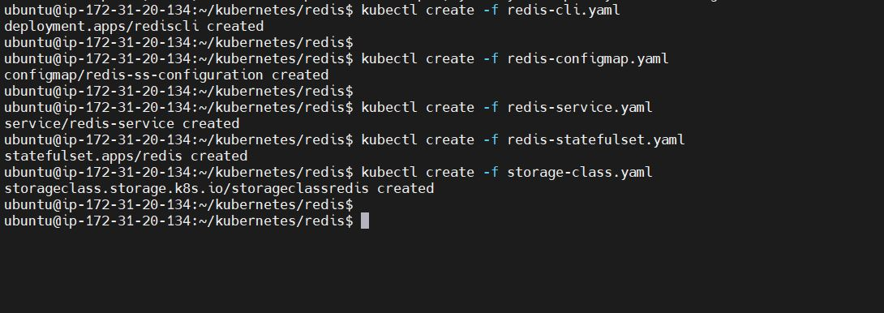

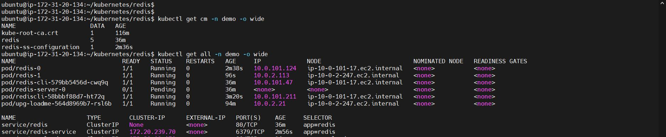

Now list all the pods and get into the redis-cli pod:

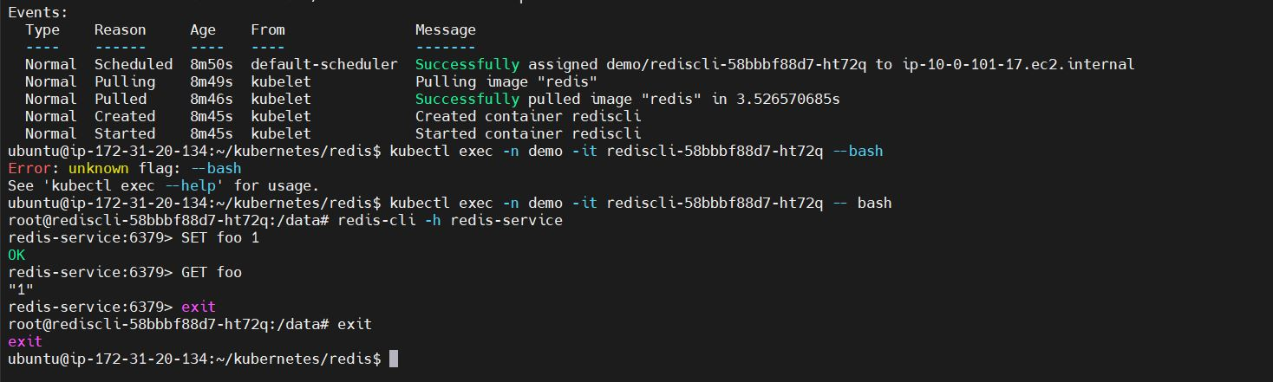

Delete the pods, check for new pods and restart the deployment :

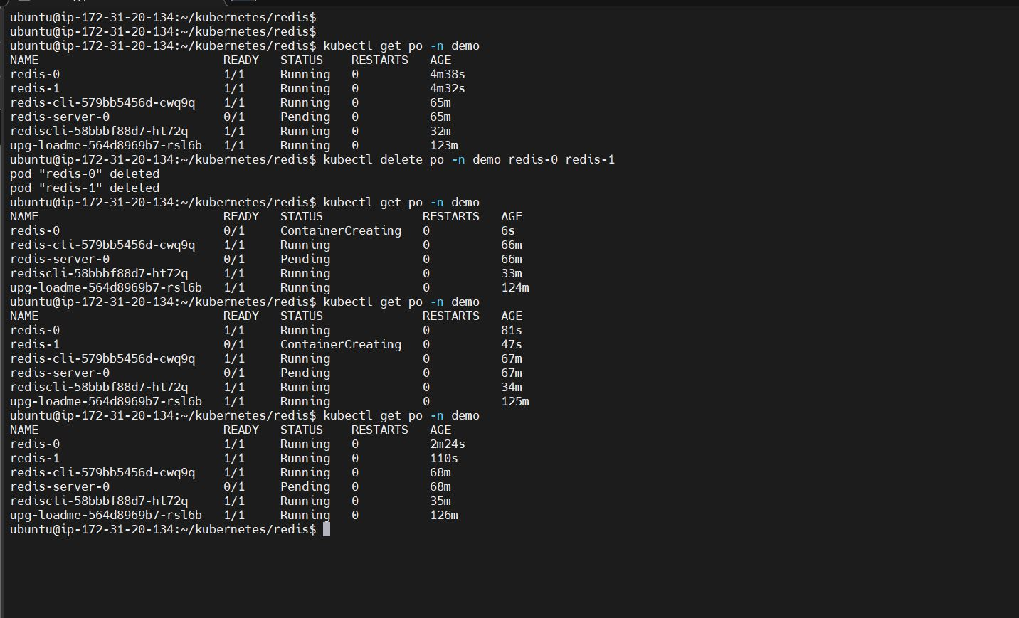

**TASK 4: Test Auto Scaling of the Application**

Deploy HPA file for the upg-loadme-app and check HPA after some time the metrics will load and can be checked with the top command:

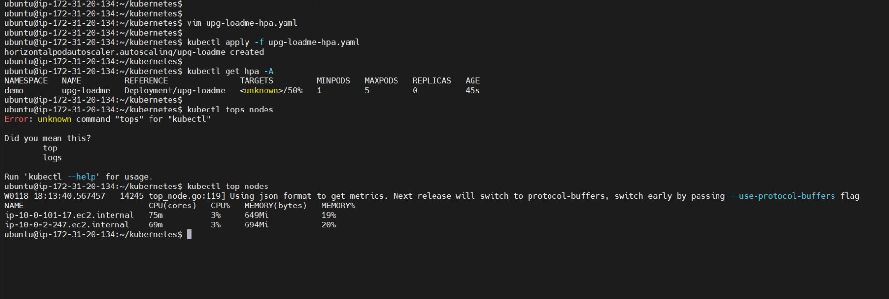

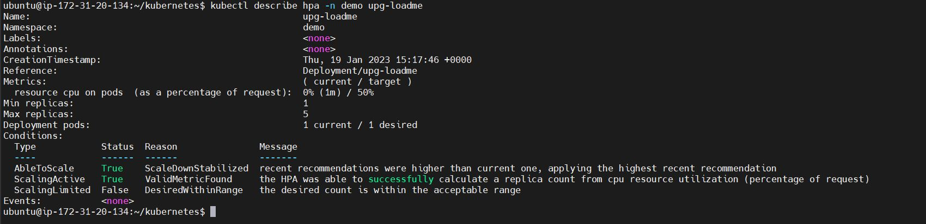

Now using the apache benchmark, scale up the nodes by increasing the load: ab -n100 -c10 'http://<INSERT-LB-DNS>/load?scale=100'

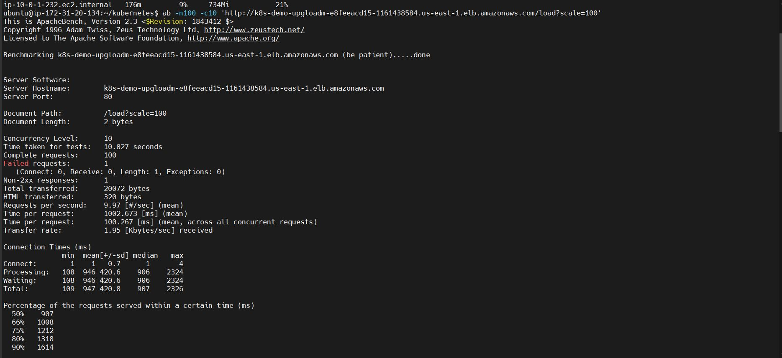

Increase the load in steps and notice the autoscaling work: Load = 150

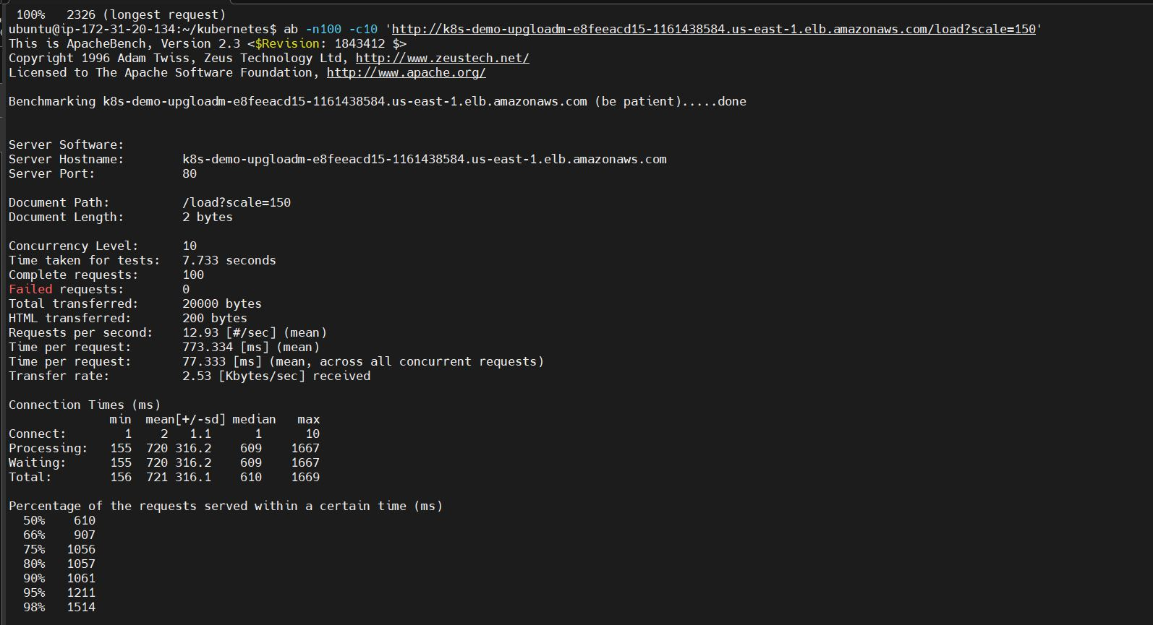

Increase the load in steps and notice the autoscaling work: Load = 250

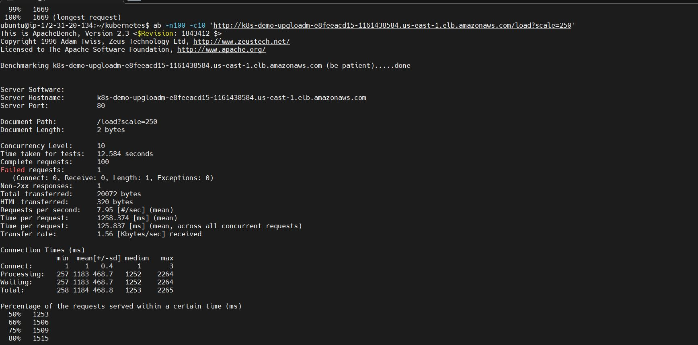

Increase the load in steps and notice the autoscaling work: Load = 300

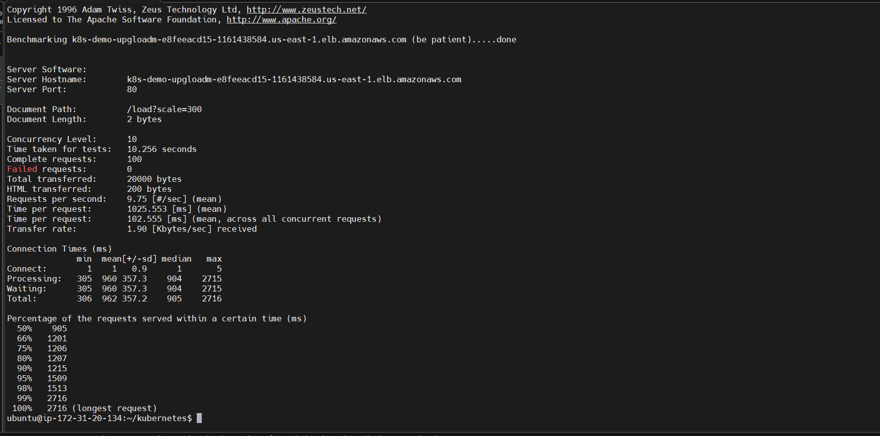

Now Install Prometheus to visualize and monitor the load on the cluster:

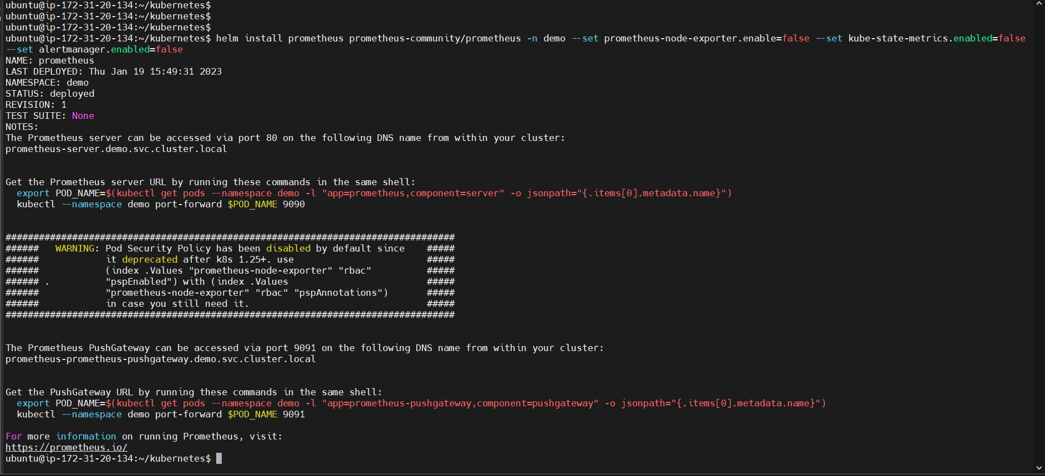

Port forward Prometheus pod and check on browser

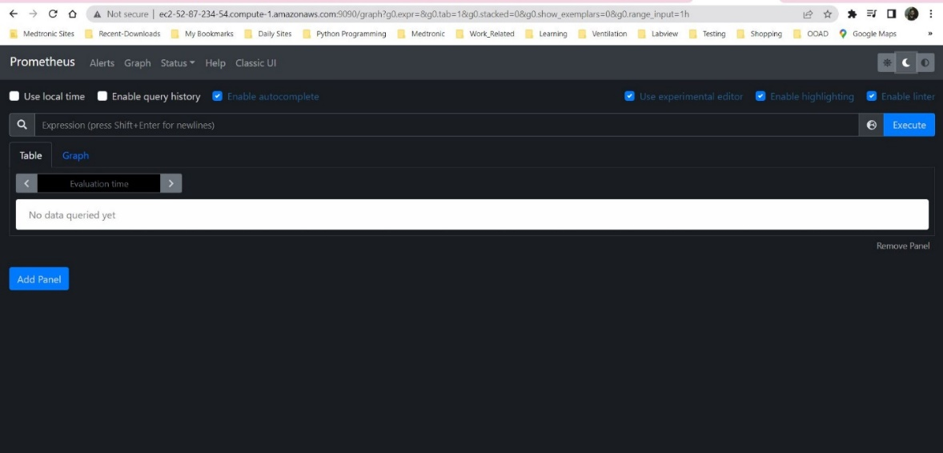

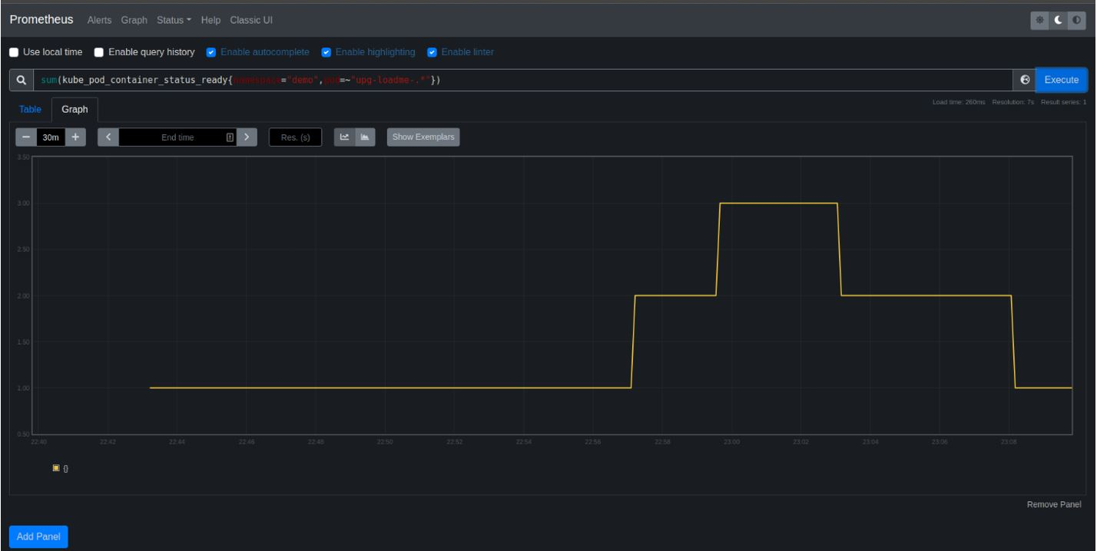

Deleted the EKS cluster : eksctl delete cluster -f my-eks-conf.yaml

